ASSIGNMENT 1. CUTTING PLANE ALGORITHM (Dantzig)

The following multicommodity network flow problem must be solved.

$\begin{matrix}Min_{x} & \sum_{l∈O}{‍}c^{Τ}x^{l} \\ s.t: & Bx^{l}=p^{l}, l∈O \\ & x^{l}≥0 \\ & \sum_{l∈O}{‍}x^{l}≤d\end{matrix}$

Seleccionem en quines nodos fixem capacitats (d).

using the cutting plane decomposition algorithm by dualizing the joint capacity constraint.

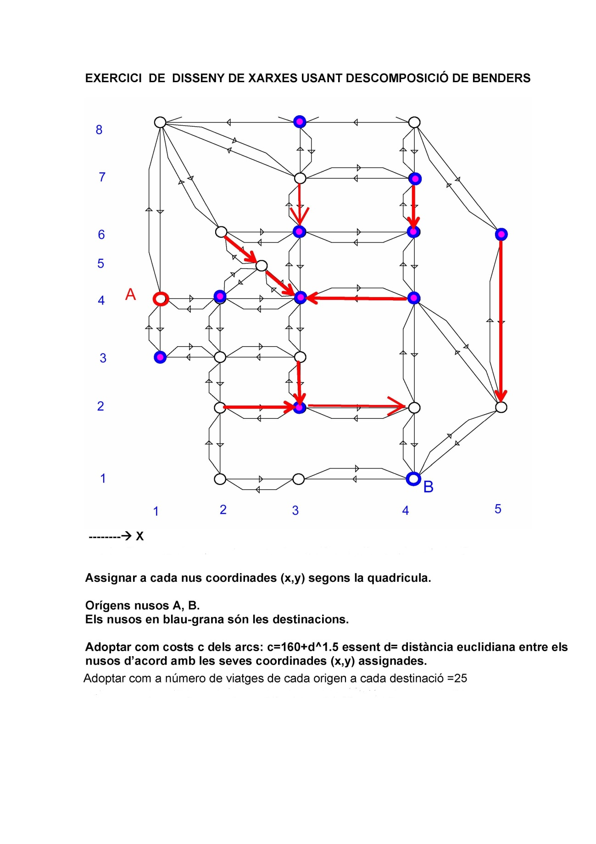

The values used in this assignment will be those of the Benders decomposition exercise. This exercise can be done in groups of two students.

To carry out the assignment follow the next steps:

1. Solve initially the problem without capacities on links, i.e.:

$\begin{matrix}Min_{x} & \sum_{l∈O}{‍}c^{Τ}x^{l} \\ s.t: & Bx^{l}=p^{l}, l∈O \\ & x^{l}≥0 \\ & \end{matrix}$

1. Report the solution and optimal function value. Then select four links and set on them a global capacity bound violated by the reported solution of the uncapacitated problem. Edit the file caps.dat with the selected values.
2. With the joint capacities on the selected links solve the capacitated problema using the AMPL files. (cuttingOGE.mod, .dat, .run, caps.dat). If the capacitated problem results unfeasible, then try with new capacity values.
3. Implement the cutting plane algorithm. Note that the algorithm requires an initial feasible solution of the capacitated problem. In order to determine one, either a) use the network’s transformation that uses an artificial node and artificial links, being the costs of associated to artificial links the constant “big-M”, or b) use AMPL to find a feasible solution by solving the capacitated problem with some other function (1’s as cost in any link…)
4. Write a report (8 pages at most) explaining the implementation of the algorithm. Report also the solution obtained (flows per origin and total flows) and the solution obtained at step 1 for the uncapacitated problem. Also, the value for the dual variables µ >=0 corresponding to the solution of the capacitated problem.
5. The evolution of the algorithm reporting for each iteration:

* Iteration number
* *z*k, *w*(*µ*k), *cTx*k+1, feasibility or unfeasibility of *x*k+1 (*x*k+1  <= d ¿)

1. Although unnecessary, solve the corresponding generalized linear programming problem equivalent to the dual of the linear problem solved in step 1 of the cutting plane algorithm reporting the solution obtained by this problem and the corresponding primal objective function value of the capacitated problem.